Supplementary Appendix

Table of Contents

Postebogui Study Group 2
Methods 3
Supplementary Figures 5
Figure S1: Cytokine profiles of PBMC from EBOV_S stimulated in vitro with EBOV peptides 5
Figure S2: Measurement of EBOV antibodies with Luminex technology 6
Figure S3: PBMC phenotypic characterization in EBOV_S 7

Postebogui Study Group

Ahidjo Ayouba (IRDUMI233-INSERMU1175-Montpellier University, Montpellier, France), Sylvain Baize (Pasteur Institute/Unit of Biology of Emerging Viral Infections, Lyon, France), Kaba Bangoura (Donka National Hospital, Conakry, Guinea), Alimou Barry (IRDUMI233-INSERMU1175-Montpellier University, Montpellier, France), Moumié Barry (Donka National Hospital, Conakry, Guinea), Mamoudou Cissé (Forecariah Prefectoral Hospital, Forecariah, Guinea), Mohammed Cissé (Donka National Hospital, Conakry, Guinea), Eric Delaporte (IRDUMI233-INSERMU1175-Montpellier University, Montpellier, France), Jean-François Delfraissy (Reacting, INSERM, Paris, France), Christelle Delmas (Reacting, INSERM, Paris, France), Alice Desclaux (IRDUMI233-INSERMU1175-Montpellier University, Montpellier, France), Saliou Bella Diallo (Donka National Hospital, Conakry, Guinea), Mamadou Safiatou Diallo (Donka National Hospital, Conakry, Guinea), Mariama Sadjo Diallo (Donka National Hospital, Conakry, Guinea), Jean François Étard (IRDUMI233- INSERMU1175-Montpellier University, Montpellier, France), Cécile Etienne (Reacting, INSERM, Paris, France), Ousmane Faye (Donka National Hospital, Conakry, Guinea), Ibrahima Fofana (Macenta Prefectoral Hospital, Macenta, Guinea), Bruno Granouillac (IRDUMI233-INSERMU1175-Montpellier University, Montpellier, France), Esther Hereth Hébert (IRDUMI233-INSERMU1175- Montpellier University, Montpellier, France), Suzanne Izard (IRDUMI233-INSERMU1175-Montpellier University, Montpellier, France), Djenaba Kassé (Donka National Hospital, Conakry, Guinea), Alpha Kabinet Keita (IRDUMI233-INSERMU1175-Montpellier University, Montpellier, France), Sakoba Keita (Ministry of Health, Conakry, Guinea), Lamine Koivogui (Institut National de la Santé Publique, Conakry, Guinea), Cécé Kpamou (IRDUMI233- INSERMU1175-Montpellier University, Montpellier, France), Christine Lacabaratz (INSERM, Paris, France), Sandrine Leroy (IRDUMI233-INSERMU1175-Montpellier University, Montpellier, France), Claire Levy Marchal (INSERM, Paris, France), Yves Levy (INSERM, Paris, France), N’Fally Magassouba (Laboratory of Virology, Conakry University, Projet de Recherche sur les Fièvres Hémorragiques en Guinée, Conakry, Guinea), Laura March (IRDUMI233-INSERMU1175-Montpellier University, Montpellier, France), Vincent Mendiboure (ALIMA, Conakry,Guinea), Philippe Msellati (IRDUMI233-INSERMU1175-Montpellier University, Montpellier, France), Harissatou Niane (Donka National Hospital, Conakry, Guinea), Martine Peeters (IRDUMI233-INSERMU1175-Montpellier University, Montpellier, France), Yves-Marie Pers (IRDUMI233-INSERMU1175-Montpellier University, Montpellier, France), Hervé Raoul (Laboratoire P4 Inserm-Jean Mérieux, US003 Inserm, Lyon, France), Sidi Lamine Sacko (Macenta Prefectoral Hospital, Macenta, Guinea), Ibrahima Savané (Macenta Prefectoral Hospital, Macenta, Guinea), Mamadou Saliou Sow (Donka National Hospital, Conakry, Guinea), Bernard Taverne (IRDUMI233-INSERMU1175-Montpellier University, Montpellier, France), Abdoulaye Touré (Department of Public Health, Conakry University, Conakry, Guinea), Fodé Amara Traoré (Donka National Hospital, Conakry, Guinea), Falaye Traoré (Institut National de la Santé Publique, Conakry, Guinea), Yamoussa Youla (N’Zérékoré Regional Hospital, N’Zérékoré, Guinea), Yazdan Yazdanpanah (Reacting, INSERM, Paris, France)

Methods

Luminex-based assays and ELISA
Twenty-nine parameters were analyzed in serum samples, by magnetic bead assays or ELISA: Human XL Cyt Disc Premixed Mag Luminex Perf Assay Kit (CCL2/MCP-1, CCL4/MIP-1β, RANTES/CCL5, CCL11/Eotaxin, CCL19/MIP-3β, CCL20/MIP-3α, CD40Ligand, Fractalkine/CX3CL1, CXCL10/IP-10, EGF, Flt-3 Ligand, Granzyme B, IL-1ra, IL-6, IL-7, IL-8/CXCL8, IL-10, IL-15, PD-L1/B7-H1, TNF-α, TRAIL/TNFSF10, VEGF).

For the Human Magnetic Luminex Assay (CD163, ST2 and CD14, LBP) (R&D Systems), plates were prepared according to the manufacturers’ recommendations and read on a Bio-Plex 200 system™. Amphiregulin, FABP2/IFABP and haptoglobin were determined with Human Quantikine ELISA Kits (R&D Systems), according to the manufacturers’ instructions.

RNA sequencing
RNA was quantified with the Quant-iT RiboGreen RNA Assay Kit (Thermo Fisher Scientific) and quality control was performed on a Bioanalyzer (Agilent). mRNA libraries were prepared with the TruSeq® Stranded mRNA kit, according to the Illumina protocol. Libraries were sequenced on an Illumina HiSeq 2500 V4 system. The sequencing depth was 50 million reads, with a fragment length of 1x100 bp. Sequencing quality control was performed with Sequence Analysis Viewer (SAV). FastQ files were generated from .bcl files on BaseSpace. After trimming (QPhred score ≥ 25) with Bowtie 2- 2.2.5 software, reads were aligned with the hg19 human reference genome, using STAR - 2.5.3ar, and quantified relative to annotation model hg19 - GENCODE Genes - release 19, with Partek E/M. Counts were normalized by the counts per million (CPM + 0.0001) method. Differentially expressed genes were identified by using normalized read counts as input for Gene-specific analysis (GSA) (Partek Flow).

Supplementary Figures

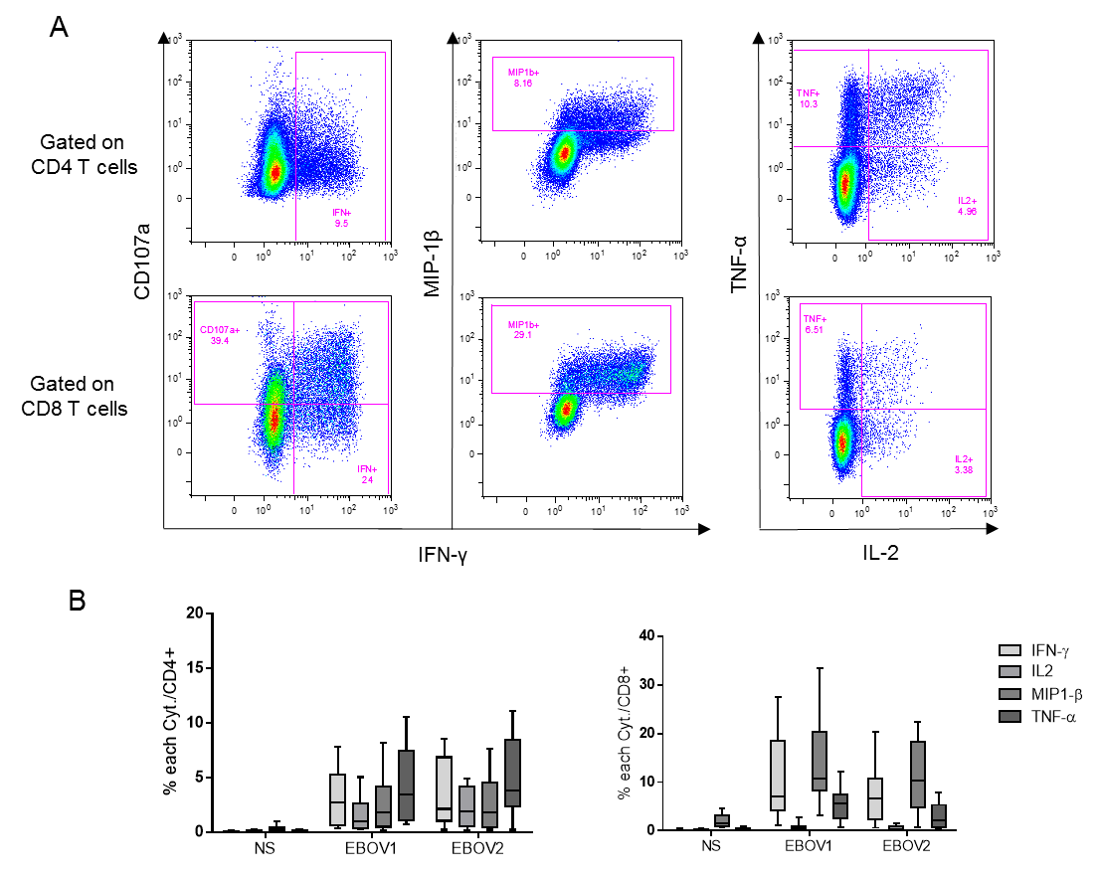
Figure S1: Cytokine profiles of PBMC from EBOV_S stimulated in vitro with EBOV peptides

Figure S2: Cytokine profiles of PBMC from EBOV_S stimulated in vitro with EBOV peptides. Representative dot plots of EBOV GP-specific CD4 T-cell and CD8 T-cell responses from EBOV_S after 9 days of EBOV GP-specific in vitro T-cell expansion (A). Frequency of CD4 T-cell producing IFN-γ, IL2, MIP-1β and TNF-α after PBMC stimulation of EBOV_S (n= 27) with 2 EBOV-GP peptide pools for 9 days. p<0.0001 per each cytokine (left). Frequency of CD8 T-cell producing IFN-γ, IL-2, MIP-1β and TNF-α after PBMC stimulation of EBOV_S (n= 27) with 2 EBOV-GP peptide pools for 9 days. p<0.0001 per each cytokine except IL-2 (p=0,013 NS/EBOV1; no difference NS/EBOV2) (right) (B). Box plots represent cumulative data of EBOV_S. The boxes define the 25th and 75th percentiles with a line at the median; error bars define the 10th and 90th.Friedman test has been used.

Representative dot plots of EBOV GP-specific CD4⁺ and CD8⁺ T-cell responses from EBOV_S after 9 days of EBOV GP-specific T-cell expansion in vitro (EBOV1 peptide pool) (A). Frequency of CD4⁺ T cells producing IFN-γ, IL2, MIP-1β and TNF-α after the stimulation of PBMC from EBOV_S (n= 27) with 2 EBOV-GP peptide pools (EBOV1 and EBOV2) for 9 days (left). P<0.0001 for each cytokine relative to non-stimulated cells (NS). Frequency of CD8⁺ T cells producing IFN-γ, IL-2, MIP-1β and TNF-α after the stimulation of PBMC from EBOV_S (n=27) with 2 EBOV-GP peptide pools (EBOV1 and EBOV2) for 9 days (right). P<0.0001 for each cytokine except IL-2 (P=0.013 NS/EBOV1; no difference NS/EBOV2) (B). Box plots represent cumulative data for EBOV_S. The boxes define the 25th and 75th percentiles, with a line indicating the median; error bars define the 10th and 90th percentiles. Friedman’s test was used.

Figure S2: Determination of EBOV antibodies with Luminex technology

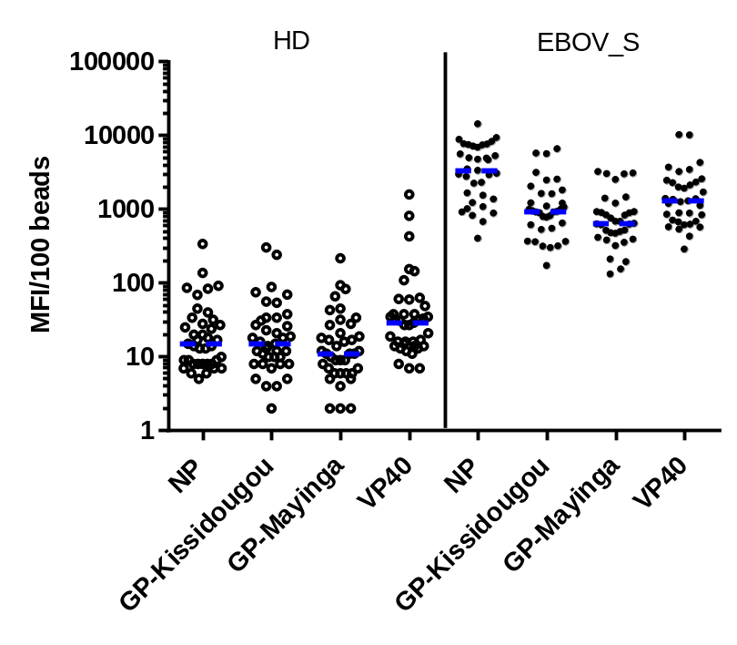
Serum samples from 39 HD (left) and plasma samples from 35 EBOV_S (right) were assessed for the presence of IgG against various recombinant Ebola virus proteins, as indicated. The horizontal dotted blue lines indicate the median MFI value. The positivity criteria were: nucleoprotein (NP): MFI≥600 and glycoprotein (GP): MFI≥400 (at least one of two GP) or positive for NP, viral protein (VP40) and 1 of 2 GP 200< MFI<399 (weak responder)

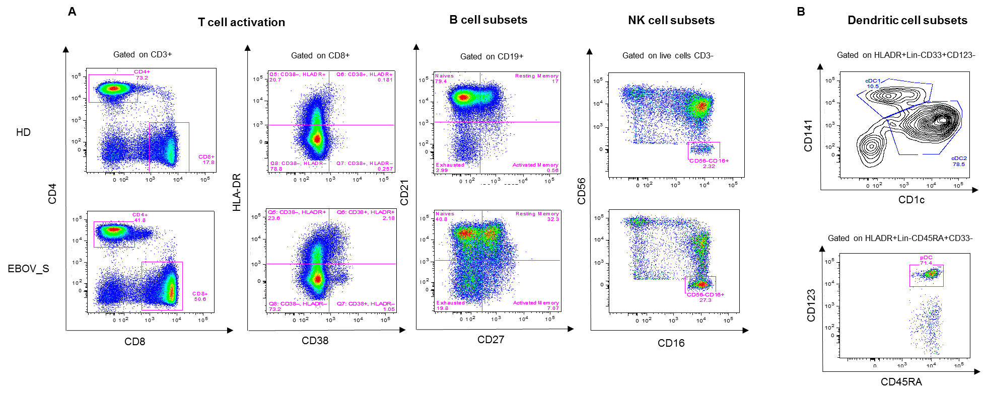
Figure S3: PBMC phenotypic characterization for EBOV_S
Representative flow cytometry results for the phenotypic characterization of PBMC from one HD (upper panel) and one EBOV_S (lower panel) (A). Gating strategy for the phenotypic characterization of DC (B).

